- Purpose
To provide Site Quality Managers with a structured checklist that clearly outlines, tracks, and supports completion of all essential quality project set-up and pre-construction tasks. By following this process, SQMs can ensure that nothing critical is overlooked, helping to establish a strong foundation for project success from the very beginning.

- Scope
This SOP applies to all EPC/BESS projects.

- Responsibilities
ROLE | RESPONSILITIES
Site Quality Manager (SQM) | Create Checklist in new Project’s Action Plan Tool in Procore  Complete Checklist throughout the Pre-Con process  Review Checklist with RQM to support progress  Provide feedback to QMS team to improve Checklist
Regional Quality Manager (RQM) | Review Action Plan created by the SQM  Provide feedback to SQM on Action Plan Items and progress  Support Checklist completion

- Procedure
  - Import the SQM Project Set-up Checklist company level template into your project
Selection Action Plans from your project’s tools menu
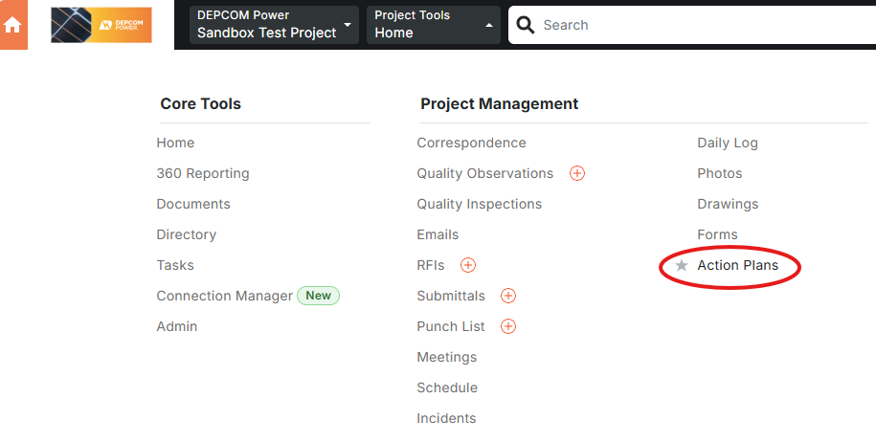
In the far right corner, click on Create and select the SQM Project Set-Up Checklist
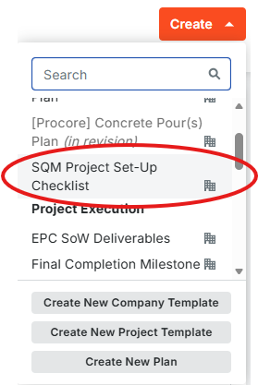

Assign the SQM as the Plan Manager. Assign the RQM as the Action Plan Approver and Completed Action Plan Receiver.
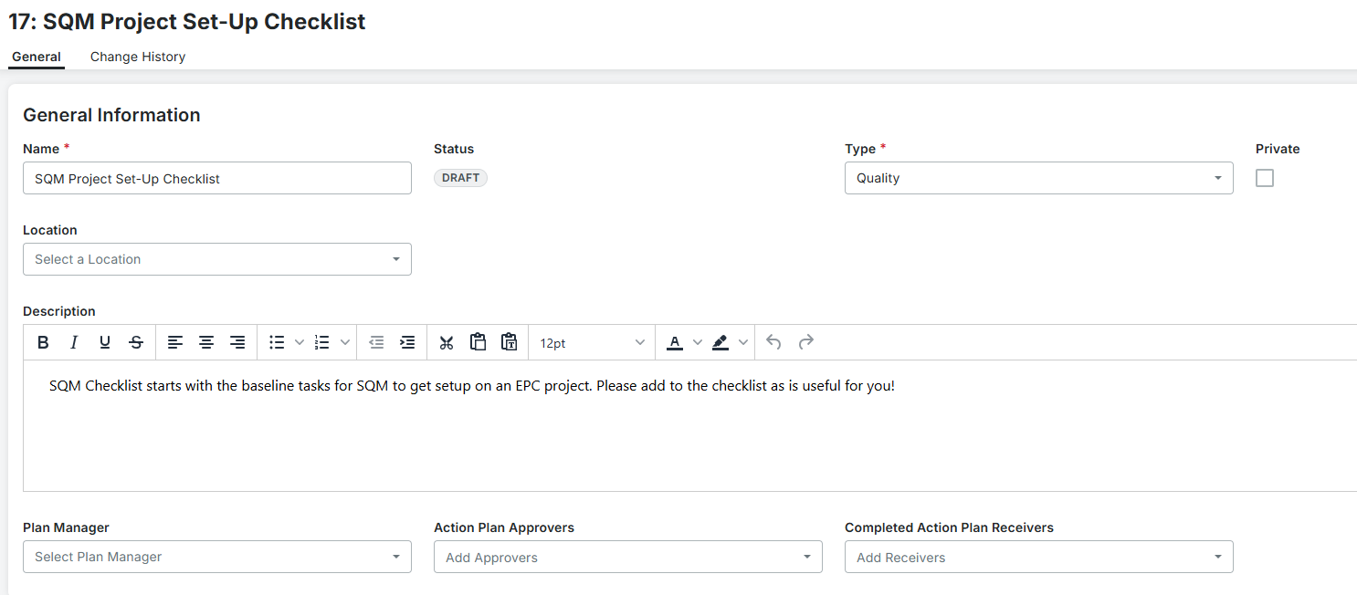

The tasks listed in this checklist are the baseline tasks necessary for a successful project setup. The SQM can add any additional tasks or sections as they wish by using the Add Item button at the bottom left of the sections or the Add Section button at the bottom of the list. Tasks and Sections can be added to the checklist at any time.
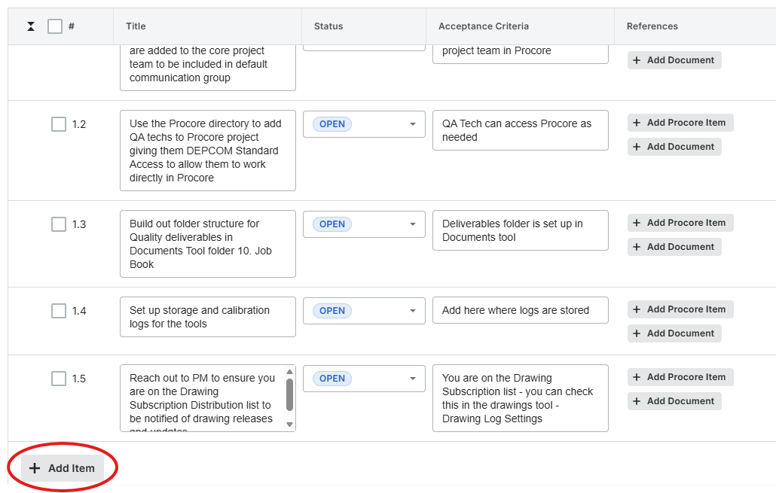
To pull the list into your project, select the orange Publish bottom at the bottom right of the list
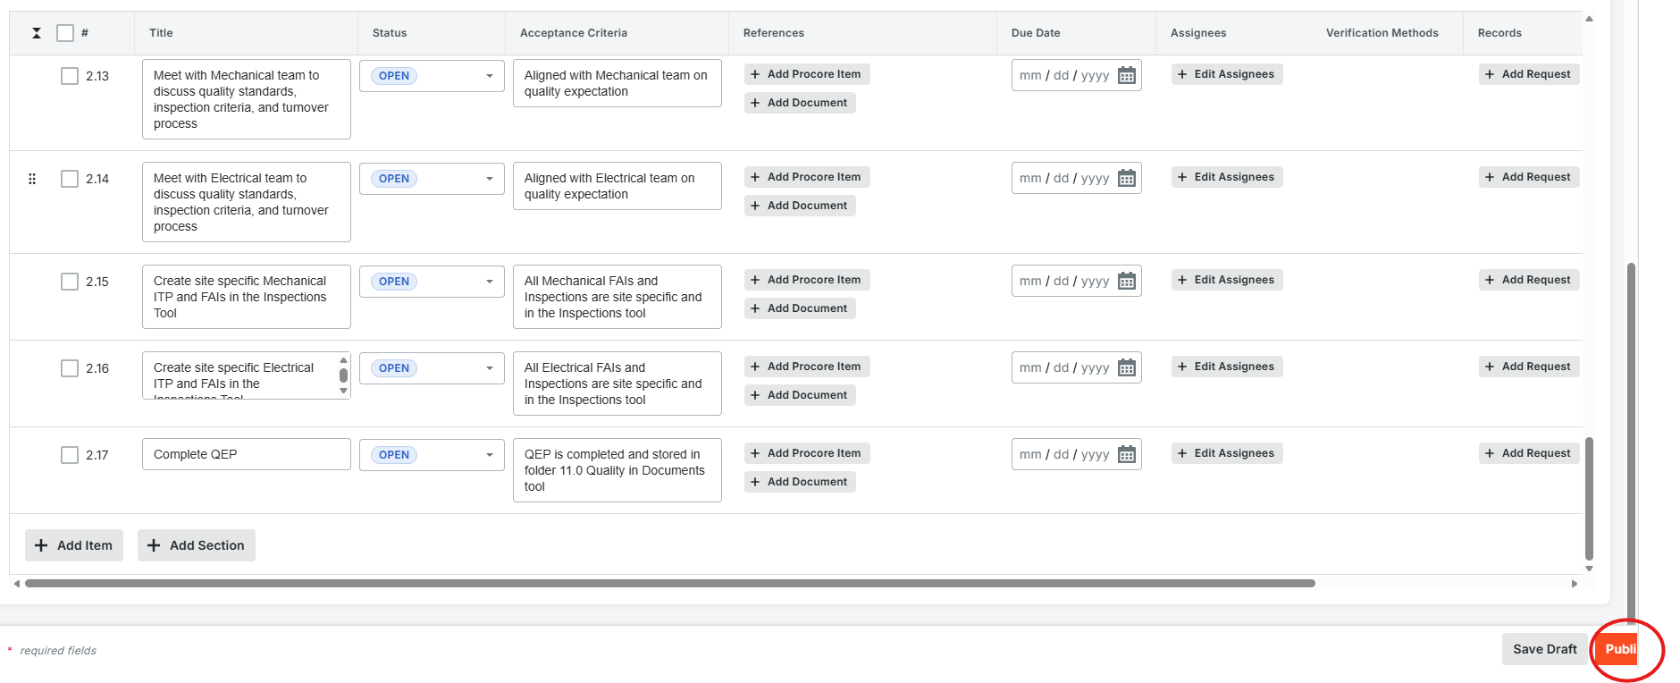

After the checklist is published, it is available in the Action Plan tool of your project
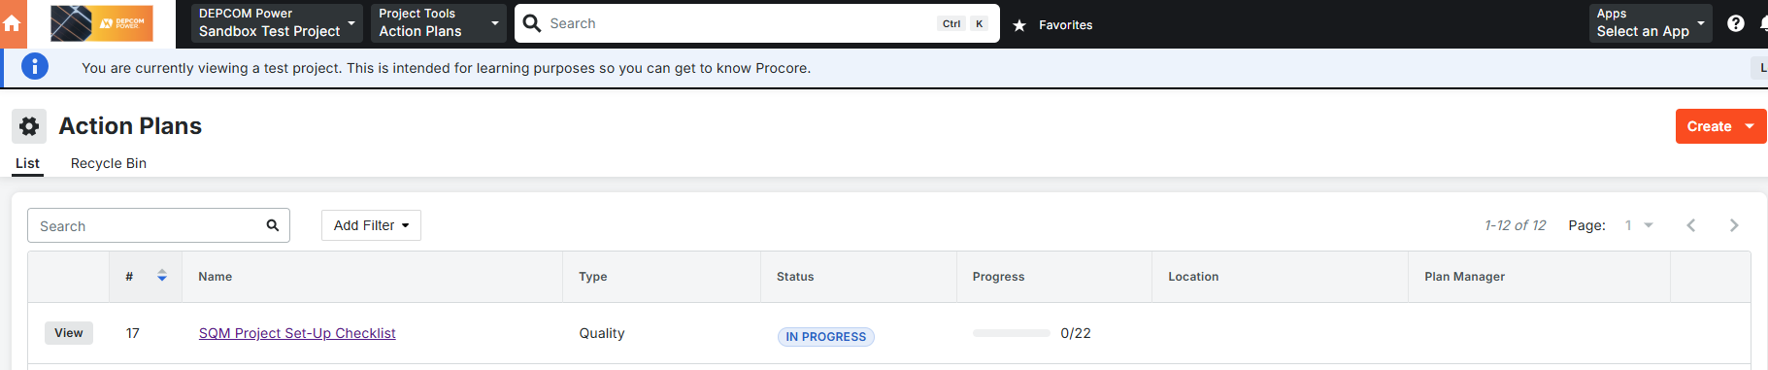

  - Change the status of items on the checklist
Got into the Action Plan tool in your project and select the SQM Project Set-Up Checklist
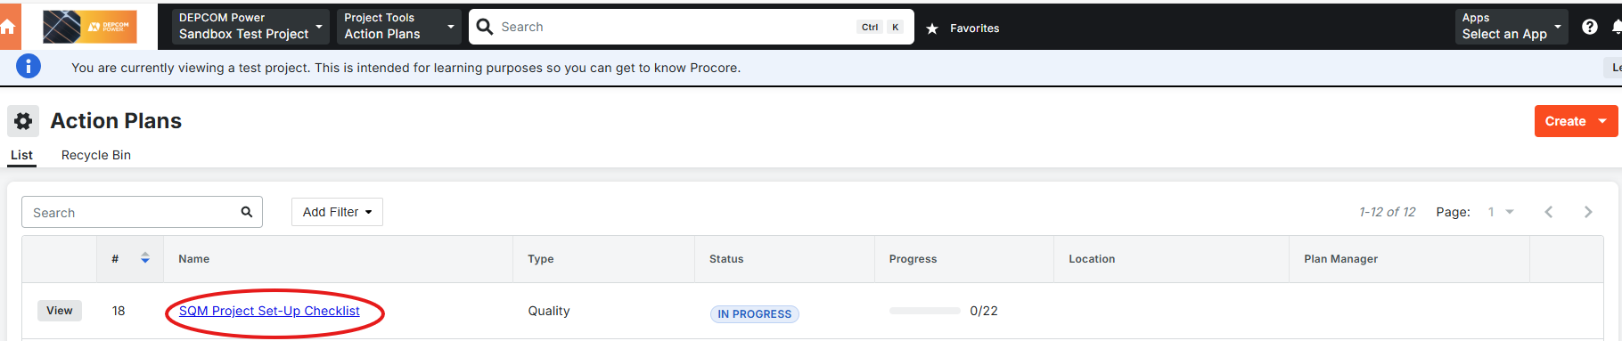

The status for each item can be changed by selecting from the dropdown menu in the status column
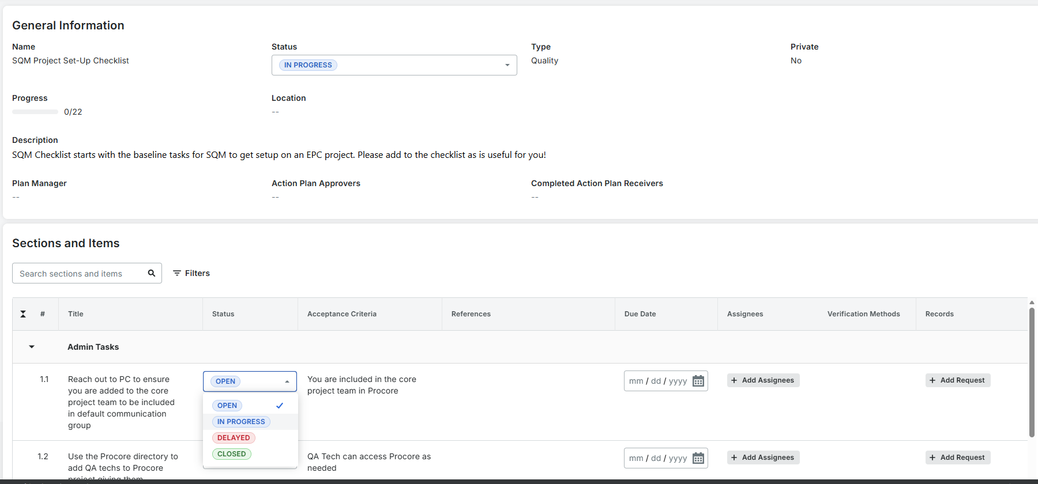

All changes made here save automatically

  - To Edit the checklist
Open the SQM Project Set-Up Checklist in the Action Plan tool of your project
Select the Edit button in the top right of the screen
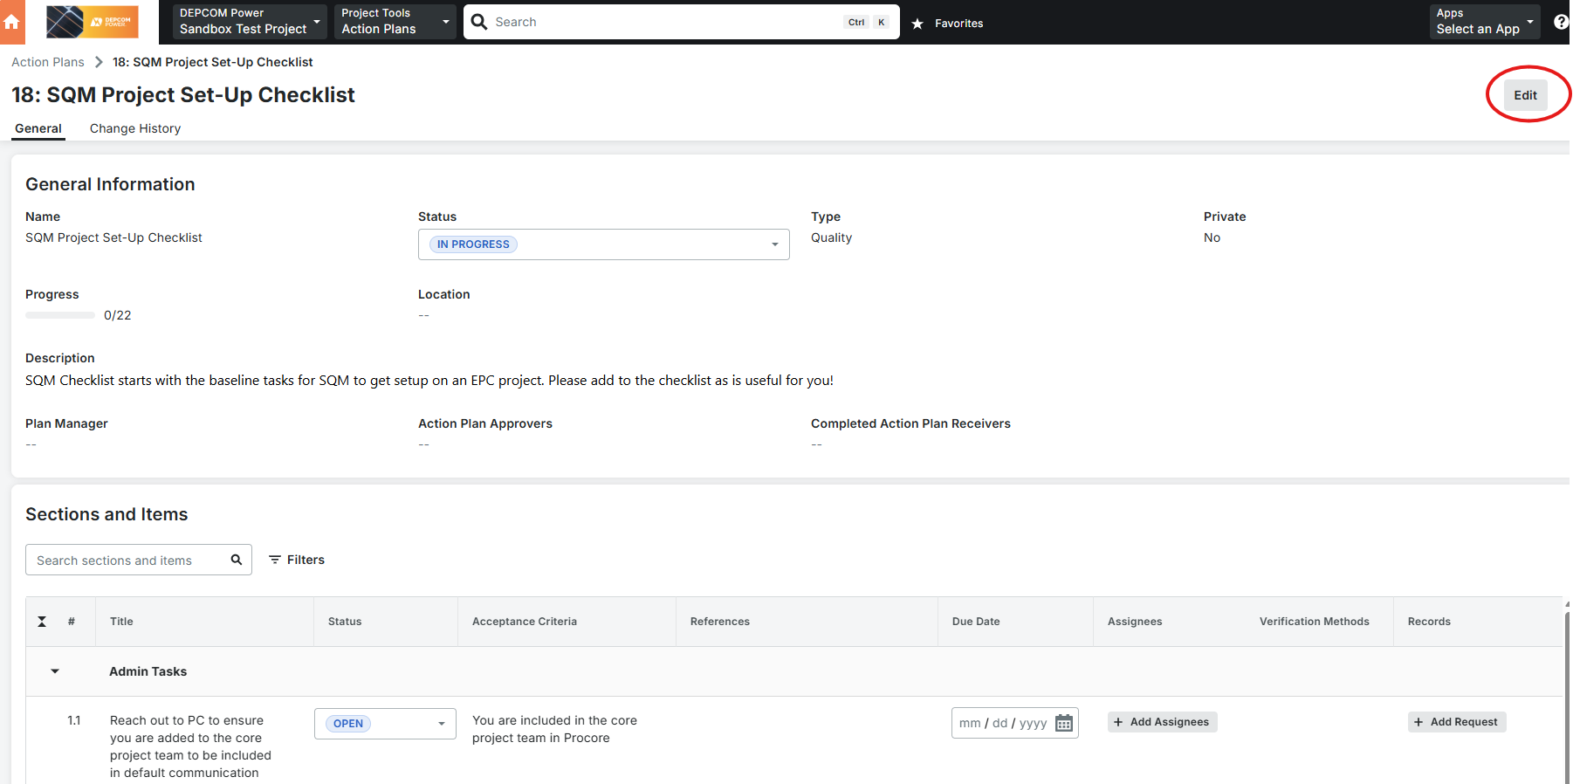

This opens the list up and allows you to add Sections and Items, change the Status, add References and Records, change Due Dates, etc

The SQM can make any additions desired, but all company template items need to remain on the list.

Select the orange Publish button at the bottom right of the list to save any Edits that are made.

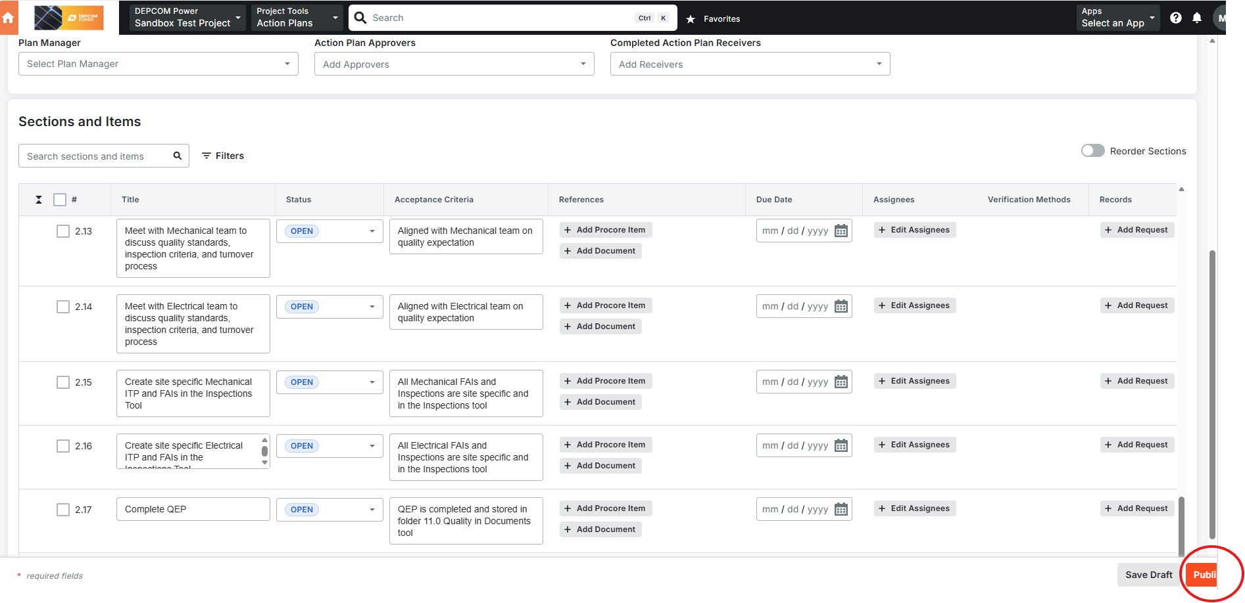

  - Use the checklist
Update the status on the checklist items as they are in progress and complete
Review checklist items with the RQM as needed to clarify items, ask for support, or show off your hard work

- Revision Table

REV. # | REV. DATE | DESCRIPTION | APPROVER
00 | 1/12/2026 | Initial Release | Jonathan Macdonald

